**Segmentation, characterization and superimposition of PSP-damage-induced dental X-ray artifacts**

Wenda Zhao

Supervisor: Prof. Pascal Tyrrell  
Department of Medical Imaging  
University of Toronto

**Abstract**

Phosphor storage plates (PSPs) are commonly used sensors for digital intraoral radiography. They have the advantage of easy placement and less discomfort but are often subject to damages. Physical damages to the plates will cause artifacts on the X-ray images that can potentially get in the way of diagnosis. Thus, knowing the relationship between the artifacts and their ability to affect diagnosis can help clinicians decide when to discard a sensor. In order to study that, we did some preparatory work of segmenting the artifacts by density-based spatial clustering of applications with noise (DBSCAN), clustering them by *k-prototypes* based on hand-engineered features and superimposing them onto clean teeth backgrounds. We segmented 1910 artifacts from 339 images and obtained 5 meaningful groups of artifacts from them. We also created a bank of 3000 superimposed artifact-containing teeth images. Our study can provide the necessary materials for building a predictive model for the effect of artifacts on diagnosis. The characterizations can serve as the input for the model and the superimposed images can be used to acquire the output labels. We also built a pipeline of image segmentation and clustering that can be used in future studies in related fields.

**Introduction**

Phosphor storage plates (PSPs) are commonly used sensors for digital intraoral radiography. They are made of a polyester base coated with phosphor particles which store a latent image in the form of energy when excited by X-rays. The energy is then released as blue fluorescent light under a helium-neon laser beam and the image is shown on a computer system1. In comparison to this indirect way of acquiring images, complementary metal oxide semiconductor (CMOS) sensors are directly connected through a cable to the computer and can display the image immediately after exposure. PSPs have the advantage of allowing easier placement in the oral cavity and causing less discomfort to the patients2. These sensors are meant to be reusable. However, after a prolonged period of use, damages accumulate on the plates and can introduce artifacts to the acquired images (see figure 1). CMOS sensors, on the other hand, are free of such damages. A study in Turkey showed that 20% of the images obtained via PSPs over a six-month period contained visible artifacts3. And PSPs-induced artifacts have been shown to adversely affect the diagnostic ability in digital mammography4. Thus, this has raised the concerns of possible missed diagnoses when using damaged sensors in dental radiography. Clinics are now dealing with this problem by discarding the plates after a certain time of use. Previous study comparing images of PSPs with different used times has suggested that each plate can be used up to 200 times without showing statistically significant changes5. However, there exists a gap between the literature and the clinics. In real life the decision of when to discard the plates is made rather arbitrarily by clinicians because of the lack of a standard protocol. This gap thus requires a model that can characterize, quantify the artifacts and give an accurate prediction as in whether a damaged sensor would impede diagnosis or not based on its characteristics. Clinicians can therefore be informed of when to discard a plate without hurting diagnosis, as a consequence of doing so too late, or wasting money, as a consequence of doing so too early. In order to accomplish this, two preliminary goals need to be achieved in preparation for building such model. The first is the characterization of dental image artifacts, which the model would then take as the input. Previous attempts have been made to categorize these artifacts. In a study done by Kalathingal *et al.*, the authors subjectively rated the damaged plates into five categories of severity in order to study the effect of wiping as a means to remove surface contaminations6. And in a recent paper published by Çalışkan and Sumer, the artifacts were placed into five categories based on their appearances: cracking, scratches, peelings of edges, bite-marks and crescent-shaped bending7. These attempts have opened up discussions on this topic but the findings were at high risk of subjectivity and bias. Thus, a more robust approach to segment and characterize these artifacts is needed. The second goal is that we need to establish a “gold standard” of whether a provided artifact will affect diagnosis. And in order to achieve that, dental images with pathologies need to be provided in the background of a representative sample of artifacts for dentists to examine. However, acquisition of such images in clinics is unlikely since it is considered unethical to knowingly use damaged sensors on patients. One way to solve this problem is to superimpose images of damaged plates onto artifact-free teeth images taken with CMOS sensors, and use the superimposed images for testing.

The purpose of our study is to help build a model that can predict the effect of dental image artifacts on diagnosis. And in doing so we face the question of whether we can segment, characterize those artifacts and superimpose them onto clean teeth images. And we hypothesize that we can achieve that by using an algorithmic and machine learning approach. Our objectives are:

1. to segment the artifacts from the image;
2. to quantify and characterize them;
3. to cluster the segmented artifacts into meaningful groups based on the characterization;
4. to superimpose images of PSPs containing artifacts onto clean teeth images taken with CMOS sensors to mimic real dental images taken on damaged PSPs.



**Figure 1.** **Phosphor Storage Plates with damage-associated artifacts.** Images from artifact image 29 (left) and 60 (right).

**Materials and Methods**

We obtained 339 PSPs with various degrees of damage from the clinics of the Faculty of Dentistry at University of Toronto.

**Data preprocessing**

**“C” removal**

There is a “C” shaped object at the right bottom corner of all the PSP images (see figure 1). It is marked on the sensor itself to help with orienting the plate. But for our study, this “C” shape could potentially be picked up by the segmentation algorithm and interfere with the process. Thus, we utilized the scikit-image8 package in python for template matching to locate and remove the “C”. The algorithm uses fast normalized cross-correlation9 to find the occurrence of a temple in an image. We cropped out a 40-pixel-by-40-pixel piece of an original PSP image with the “C” in the middle to serve as a template for the algorithm. The algorithm returns a correlation matrix showing the similarity between the template and the pixels across the entire tested image, with the maximum value being at the centre of the matched area. We then set all pixels, whose value is larger than 45, within a radius of 20 from the matched point to a value of 20.

**Histogram equalization**

Histogram equalization is a way to improve the contrast of images by spreading out the frequently appearing intensity values. In our case, this could prove to be helpful because it can potentially show the subtle artifacts present on the plates that are not necessarily visible to human eyes. Global histogram equalization works by transforming the entire image to obtain a linear cumulative distribution function of the histogram10. However, it also comes with the problem of over-brightness and noise. Instead, Contrast Limited Adaptive Histogram Equalization (CLAHE) performs histogram equalization on small blocks of the image and applies contrast limiting, which clips any histogram bin above a certain contrast limit before equalizing, to reduce noise11. Block size and clip limit are two hyperparameters that can be adjusted. We used an OpenCV implementation of CLAHE with a block size of 64 pixels by 64 pixels and a clip limit of 4.0 based on the performance of various testing values.

**Segmentation**

Density-based spatial clustering of applications with noise **(***DBSCAN*) is a data clustering algorithm initially proposed by Ester *et al.*12 in 1996, and does, as the name suggests, density-based clustering that groups spatially close points together. The algorithm searches the *ɛ* neighborhood of a point, which is the multidimensional space within a distance *ɛ*, calculated by some distance metrics, usually the Euclidian distance, from that point. If there are more than a certain number of points, denoted *MinP*, in that neighborhood, the data point is then considered a core point and a cluster is started. All the points within the neighborhood of a core point are termed reachable from the core point and are all part of that cluster. The *ɛ* neighborhoods of all cluster members, if again contains more than *MinP* points, are also termed reachable from the original core point and are thus grouped into the same cluster, so on and so forth. In other words, reachability can be passed on from one core point to another core point in its neighborhood. Any point that is not reachable from other points is grouped into noise. The *DBSCAN* algorithm contains two hyperparameters: *ɛ* and *MinP*. In our study, we chose 20 for both based on clustering results from several testing values. In order to reduce the noise, we also thresholded our images by setting any pixel below 65 to 0. We used the scikit-learn13 package in python for *DBSCAN* implementation. Our inputs are in the form of sparse matrices: SciPy14 COO matrices of triplet (row, column, intensity) tuples. The algorithm returns a cluster label for each pixel on the image.

**Feature computation**

We picked the following 9 features to be calculated from each segmented artifacts: number of pixels to represent the area of artifacts; sum of intensity to represent the volume; range along *x* and *y* axes to represent the length and width; *x* and *y* coordinates of the centroid to represent the location; maximum and median intensity to represent the intensity; and a categorical variable of shape to be either line, triangle, rectangle or circle. Because centrosymmetric locations on the plates are equivalent to each other in clinical settings, we used the location of the centroid with respect to the centre of the image instead of to the origin of the coordinate plane, which is usually the bottom left corner. We also omitted minimum intensity as a feature because we applied a lower threshold of 65 during *DBSCAN* segmentation, which made 65 to be the minimum in many artifacts.

For shape detection, we utilized the contour of the segmented artifacts. An OpenCV15 package for contour approximation was used to approximate the contour with a shape of fewer vertices within a range of error *ɛ*, which we picked to be 4% of the contour perimeter. The algorithm is an implementation of the Ramer–Douglas–Peucker algorithm16, 17, and it returns a list of vertices for the approximating shape. With two vertices, it means the shape of interest can be approximated by a line; whereas three vertices indicate a triangle; four being a rectangle, etc. We put artifacts that can be approximated by a polygon with more than four vertices into the category of circle.

**Clustering**

*K-prototypes* is a clustering algorithm that can be used to partition large datasets containing both numerical and categorical variables into *k* homogeneous groups, where k is a hyperparameter representing the number of clusters desired18. The algorithm is based on the *k-means* paradigm that minimizes a dissimilarity metrics between data points and the clusters through multiple iterations. In *k-means*19, which can only be used for numerical variables, the dissimilarity is measured by a distance function, usually the Euclidean distance, between the data points and the centroids of the clusters. The centroids are first randomly initiated. After computing the distance metrics, every data point is assigned to its closest cluster. Then the centroids of the clusters are recalculated based on the updated results and the next iteration of computing and reassignment starts. This will go on until convergence where assignments no longer change. Another derivation of *k-means* called *k-modes*20 is used for categorical variables only. It uses the number of mismatches between the data points and the modes of the clusters as a measure of dissimilarity and also goes through multiple iterations of computing and reassigning until the algorithm converges. *K-prototypes* combines the two algorithms together and calculates the dissimilarity by a weighted combination of that of *k-means*, for numerical variables, and that of *k-modes*, for categorical variables, and is thus able to perform clustering on data sets containing both types of data. Here we used a package developed by Nico de Vos for python implementation of *k-prototypes*21. All numerical variables were standardized before applying *k-prototypes* by using a MinMaxScaler from the scikit-learn package that scales each feature to a given range:

where [*min*, *max*] is the range to which the data is to be scaled, and in our case, [0, 1].

**Superimposition**

Our superimposition was experimented on 23 selected artifact images from the 339-image-bank. All artifact images were superimposed onto one CMOS image of teeth taken from a dental mannequin. Images taken directly with the same 23 damaged plates on the same mannequin were also acquired for validation purposes.

Several algorithms were tested for superimposition of image artifacts onto clean dental images. The simplest way is to linearly combine the two images with different weights for each:

where *a* is the matrix form of the artifact image in NumPy array22, *b* is the clean teeth background and *c* is the final superimposed image. *W1* and *w2* stand for the weight constant applied to the artifact and background.

Given the complexity and heterogeneity of the artifacts within one image, one might consider applying different weights for different intensity regions of the artifact masks:

Here *a*(*k*) corresponds to the *k*th intensity region of the artifact image containing all elements of *a* with intensity values between *mk* and *Mk*. To incorporate all possible intensity values of our 8-bit grey scale images, *mk* of the first region and *Mk* of the last region should be 0 and 255, respectively. And the upper limit of one region should be the same as the lower limit of the next region. *W1k* is the weight designated for the *k*th region of the artifact masks and *w2* is a constant weight applied to the entire image of the teeth background.

Instead of a discontinuous weighting function such as in the thresholded weighting approach, our other attempt involved using a continuous weighting function that assigns weight for each pixel to be a function of their intensity. Based on the assumption and observation that subtle artifacts need to be more prominent in the final superimposed image than those readily bright artifacts, we chose a continuous, monotonically increasing function, exponential function, to be our weighting function:

Thus, the final image was constructed element-wised where the value of each superimposed pixel *cij* was the sum of the corresponding pixel *bij* in the teeth background weighted again by a constant *w2* and the corresponding pixel *aij* in the artifact masks weighted by *wij*, an exponential transformation of its own intensity. *A* and *B* are the constant coefficient and the base of the exponential function, respectively.

**Results**

**“C” removal**

After implementing the template matching algorithm using a “C” template cropped out from one of the images, the “C”s in all artifact images were successfully located. It was then removed by setting all pixels within a radius of 20 from the matched point whose value is larger than 45 to a value of 20 (see figure 2).



**Figure 2.** **Removal of the “C” in artifact images.** Image from artifact image 60. The bright “C” at the right bottom corner of the artifact image was no longer present (see red arrow). However, a dark negative image of what used to be the “C” could still be seen.

**Histogram equalization**

We decided to apply histogram equalization before doing superimposition because a lot of the artifacts were barely visible due to low intensity and contrast. The histograms of the original artifacts showed that most of the pixels were within the intensity range of 30-70 (see figure 3*d*). After global histogram equalization, many subtle artifacts appeared to be brighter (see figure 3*b*). However, there was also a lot of background noise. The histogram showed that pixel intensity was much more spread over the entire range now but was almost exclusively constricted to a discrete set of values (see figure 3*e*). CLAHE, on the other hand, enhanced the artifacts without introducing too much noise (see figure 3*c*). The histogram showed more spread of intensity comparing to before, but it also retained its original shape (see figure 3*f*).

**Segmentation**

We used the DBSCAN algorithm to segment the artifacts from the background (see figure 4). Large, bright artifacts were easily picked up, whereas some of the more subtle, dimmer artifacts were not detected. Artifacts around the edges are generally better captured by the algorithm. Based on the results, we were able to create images with single segmented artifacts on a black background (see figure 4) to be used for further artifact-wise feature extraction.

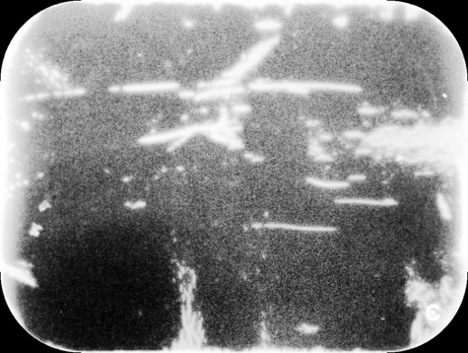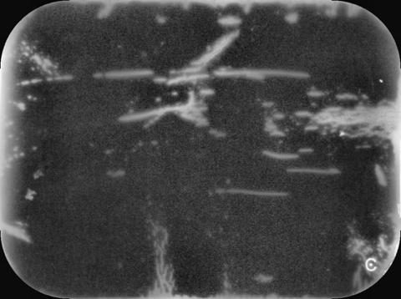

*a*

*b*

*c*

*d*

*e*

*f*

**Figure 3. Global and contrast limited adaptive histogram equalization of artifact images.** Images from artifact image 29. Shown here *a*-*c*: original artifact, artifact after global equalization and artifact after CLAHE; *d*-*f*: histogram of original artifact, artifact after global equalization and artifact after CLAHE.



**Figure 4. Artifact detection by DBSCAN.** Shown here *a* and *b*: artifact image 60; *c* and *d*: image 29. Parameters: *ɛ* = 20, *MinP* = 20. All images were thresholded at 65. Each detected artifact was represented in a unique color. Large, bright artifacts (see red arrows) were able to be detected, whereas many subtle, dimmer artifacts (see white arrows) were missed.

*a*

*b*

*c*

*d*



**Figure 5. Individual segmented artifacts.** Shown here *a*-*d* are different individual artifacts in artifact image 60 segmented by the DBSCAN algorithm.

*a*

*b*

*c*

*d*

Based on the results, we were able to create images with single segmented artifacts on a black background (see figure 5) to be used for further artifact-wise feature extraction.

**Feature computation and clustering**

We calculated 9 features for each segmented artifact, namely area, volume, length, width, centroid *x* location, centroid *y* location, maximum intensity, median intensity and shape. The first eight features are numerical variables whereas shape is a categorical variable of 0, 1, 2 and 3, representing line, triangle, rectangle and circle, respectively. We performed *k-prototypes* clustering on these 9 features with *k*=5 and obtained 5 clusters. To better visualize the results, we used boxes of 5 unique colors to show the artifacts in their cluster (see figure 6). Out of the 1910 artifacts that we segmented from 339 images, 261 of them belong to Cluster 0, represented in blue; 279 artifacts are in Cluster 1, represented in red; 532 in Cluster 2, shown in green; 280 in Cluster 3, shown in pink and 558 in Cluster 4, shown in yellow. We calculated the mean of all

**Figure 6. Clustering of artifacts by *k-prototypes*.** Examples here are from artifact image 29 (left) and 60 (right). Each color represents a different cluster determined by the algorithm: Cluster 0, 1, 2, 3, 4 shown in blue, red, green, pink and yellow, respectively (see arrows).



features for each cluster (see table 1) and, based on their absolute and relative magnitude, gave a qualitative description of the prototypical artifact for each cluster (see table 2).

Based on the mean values for all the features, Cluster 0 seems to have the characteristics of median size, high intensity, narrow shape, and being on the edges, whereas Cluster 1, in comparison, is very similar but has larger size yet lower intensity. Cluster 3 can be described as bright, small, triangular artifacts around the corner, while Cluster 4 consist also of small polygonal artifacts but of lower intensity and are in the mid area of the image. Cluster 2 has a blend of the above characteristics: triangular in shape and resides on the lateral edges.

Table 1: Mean feature values of artifact clusters.

|  |  |  |  |  |  |  |  |  |  |
| --- | --- | --- | --- | --- | --- | --- | --- | --- | --- |
| Cluster | Num. Pixels | Volume | Delta X | Delta Y | Centroid X | Centroid Y | Max Intensity | Median Intensity | Shape |
| 0 | 998 | 150486 | 11 | 176 | 569 | 80 | 227 | 181 | 0.53 |
| 1 | 8487 | 679394 | 85 | 586 | 559 | 76 | 189 | 75 | 2.20 |
| 2 | 1278 | 101825 | 12 | 184 | 551 | 115 | 126 | 75 | 0.83 |
| 3 | 512 | 81779 | 65 | 33 | 436 | 364 | 195 | 151 | 1.51 |
| 4 | 245 | 19266 | 79 | 16 | 278 | 357 | 93 | 73 | 1.83 |

Table 2: Descriptive features of artifact clusters

|  |  |  |  |
| --- | --- | --- | --- |
| Cluster | Color | # of artifacts in cluster | Description |
| 0 | Blue | 261 | Median sized narrow linear peelings of the lateral edges with high intensity |
| 1 | Red | 279 | Large narrow rectangular peelings of the lateral edges with median intensity |
| 2 | Green | 532 | Median sized triangular peelings of the lateral edges with median intensity |
| 3 | Pink | 280 | Small triangular peelings of the corners with high intensity |
| 4 | Yellow | 558 | Small polygonal blobs in the mid area of image with low intensity |

We also plotted the distribution of each individual feature within every cluster (see figure 7). The results match the description given by looking at the mean of every feature. For example, Cluster 1,2 and 3 have a high number of artifacts with high centroid X value, which means these artifacts are located along the lateral edges of the image. Looking at the categorical variable, the shape of Cluster 0 is predominantly “line”, which agrees with the “linear, narrow” description.

To validate the independence between selected features, we calculated the Pearson’s correlation coefficients *r* between each individual pair of features and obtained a matrix of correlation coefficients (see table 3). Most variables are not strongly correlated with each other. However, there is a very strong correlation between the number of pixels and the volume of the artifacts (*r* = 0.976). The width of the artifacts also has a moderate correlation with both number of pixels and volume (*r* = 0.669 and 0.659). The two measurements of intensity chosen, maximum intensity and median intensity also have a moderate correlation with each other (r = 0.665).

**Figure 7. Distribution of selected features within each cluster.**

Centroid X

Centroid Y

Delta X

Delta Y

Max Intensity

Median Intensity

Num. Pixels

Shape

Volume

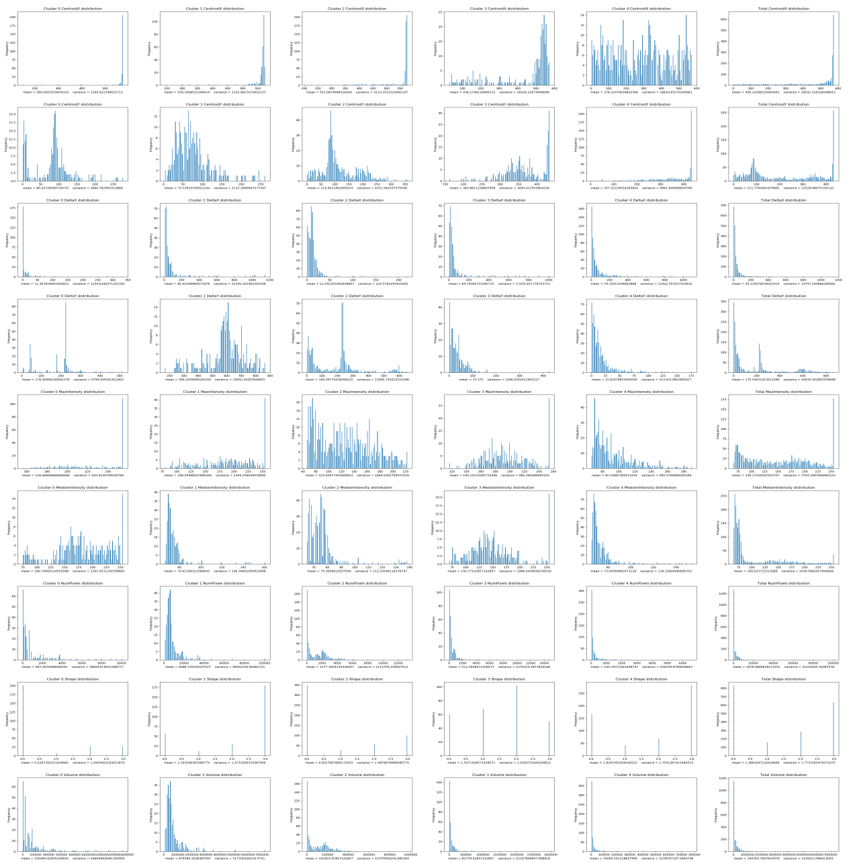

Cluster 0

Cluster 2

Cluster 1

Cluster 3

Cluster 4

Total

Table 3: Correlation analysis of selected features

|  |  |  |  |  |  |  |  |  |  |
| --- | --- | --- | --- | --- | --- | --- | --- | --- | --- |
|  | Num. Pixels | Volume | Delta X | Delta Y | Centroid X | Centroid Y | Max Intensity | Median Intensity | Shape |
| Num. Pixels | 1.000 | 0.976 | 0.442 | 0.669 | 0.147 | -0.301 | 0.258 | -0.134 | 0.057 |
| Volume | 0.976 | 1.000 | 0.470 | 0.659 | 0.148 | -0.297 | 0.333 | -0.055 | 0.043 |
| Delta X | 0.442 | 0.470 | 1.000 | 0.090 | -0.319 | 0.239 | 0.063 | -0.019 | -0.003 |
| Delta Y | 0.669 | 0.659 | 0.090 | 1.000 | 0.452 | -0.604 | 0.387 | -0.150 | -0.026 |
| Centroid X | 0.147 | 0.148 | -0.319 | 0.452 | 1.000 | -0.632 | 0.381 | 0.126 | -0.146 |
| Centroid Y | -0.301 | -0.297 | 0.239 | -0.604 | -0.632 | 1.000 | -0.306 | -0.024 | 0.083 |
| Max Intensity | 0.258 | 0.333 | 0.063 | 0.387 | 0.381 | -0.306 | 1.000 | 0.665 | -0.190 |
| Median Intensity | -0.134 | -0.055 | -0.019 | -0.150 | 0.126 | -0.024 | 0.665 | 1.000 | -0.183 |
| Shape | 0.057 | 0.043 | -0.003 | -0.026 | -0.146 | 0.083 | -0.190 | -0.183 | 1.000 |

*Red/green color indicates a strong positive/negative correlation whereas yellow indicates a weak correlation.

**Superimposition**

We superimposed 30 selected artifact images each onto 100 CMOS real patient teeth images with or without pathology and obtained a dataset of 3000 images of teeth with artifact masks (see figure 8 as an example).

Our superimposition algorithm used an exponential weighting function to combine the equalized artifact images and the teeth background pixel-wise to generate a final superimposition. We then segmented the very bright artifacts from the original artifact images using a lower threshold and used that to replace their counterparts in the superimposition (see figure 9). After several testings of different values, we used points (30, 0.1) and (255, 0.5) to obtain *A* = 0.08069, *B* = 1.00718 for the exponential function .

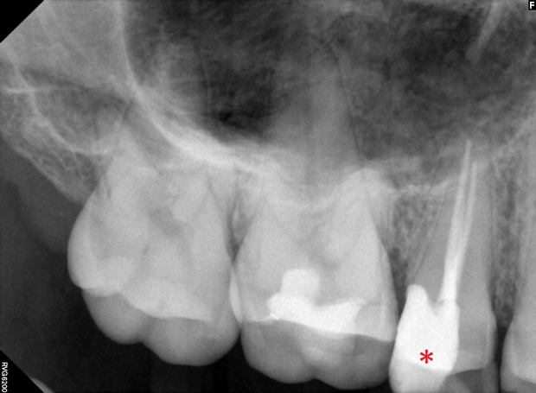

**Figure 8. Superimposition of artifact masks onto patient teeth images.** Left side from top to bottom: artifact image 60, patient teeth image 001, superimposition. Right side from top to bottom: artifact image 29, patient teeth image 001, superimposition. Red asterisk indicates the tooth where the pathology might be.

Before adopting this algorithm, we experimented with some other ways of superimposition. Our first attempt involved directly combining the two images linearly (see figure 10*a*). After testings of several values, the weights for the artifact mask and teeth background were determined to be 0.6 and 0.4 respectively.

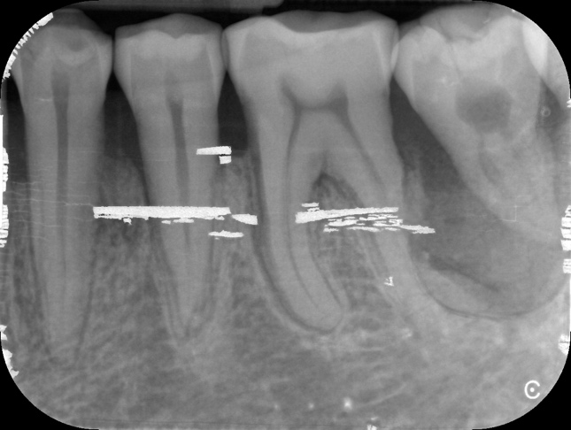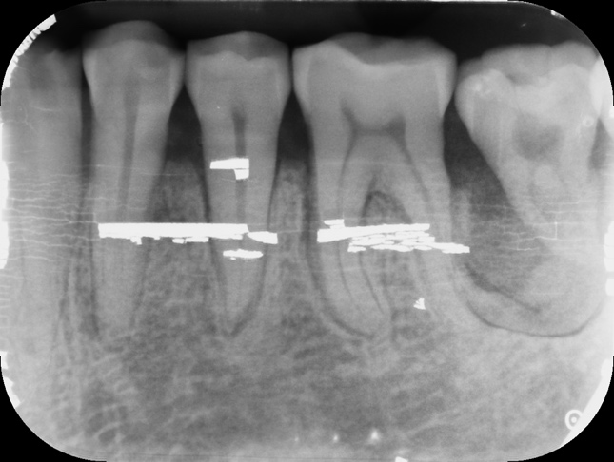

**Figure 9. Superimposition by exponential weighting.** Shown here *a*: superimposition using exponentially weighted enhanced artifact images with replacements of bright artifacts from original artifact images. *b*: “gold standard”. Image from artifact image 60.

*a*

*b*

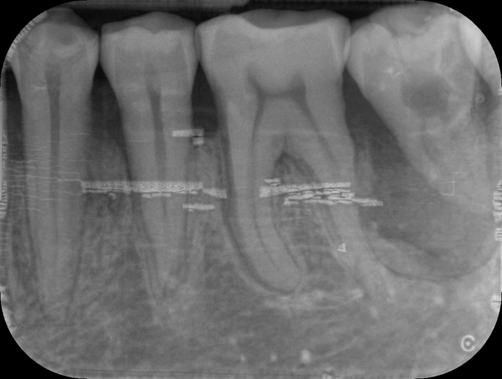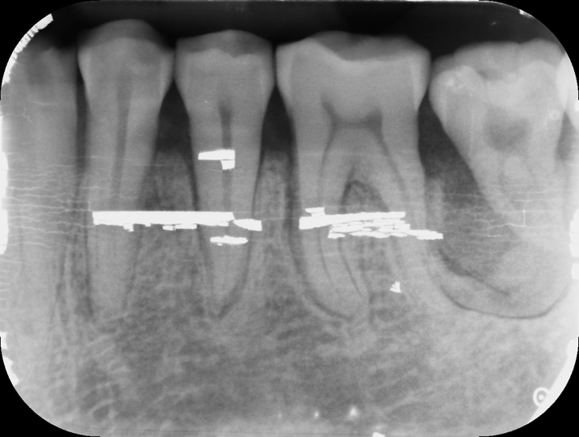

*a*

*b*

**Figure 10. Superimposition by linear combination.** On the left is the superimposition of an artifact-containing PSP image and an artifact-free CMOS teeth image. On the right is the image of the same set of teeth taken directly on the same damaged PSP as a “gold standard”. Image from artifact image 60.

**Figure 11. Superimposition by thresholding.** Shown here*a*: superimposition with original artifact image. *b*: superimposition with enhanced artifact image. *c*: “gold standard”. Image from artifact image 60.

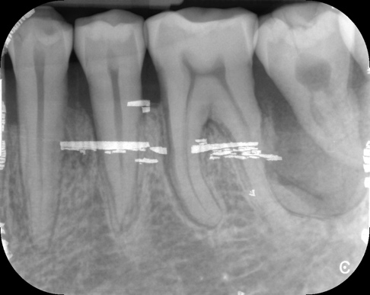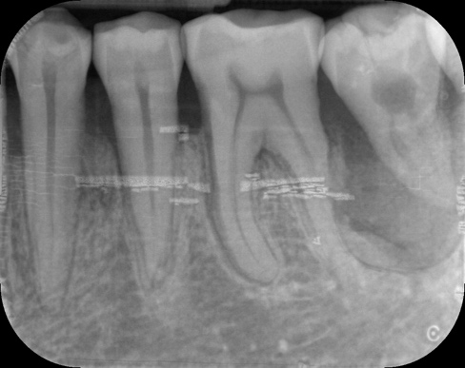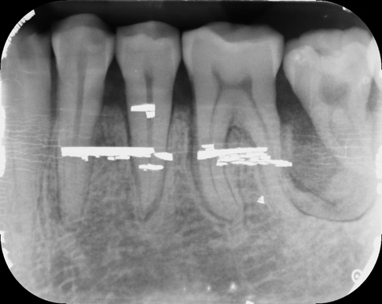

*a*

*b*

*c*

Our second attempt was to use different weights for different regions of intensity. Both the original artifacts and the equalized artifacts were used for this. After some experimenting, we decided to threshold the original artifacts images to three regions of intensity: 0-30, 30-120, 120-255; with weights of 1.5, 1.2 and 1 respectively (results shown in figure 11*a*). The weight for the CMOS teeth background was 0.8. For the equalized artifact images, we set the thresholds to 0-70, 70-150 and 150-255, with weights of 0.2, 0.5 and 0.7. The weight for the CMOS teeth background was 0.8 (results shown in figure 11*b*).

**Discussion**

In this study, we segmented the PSP-damage-induced dental X-ray artifacts using the DBSCAN algorithm; generated meaningful clusters of the segmented artifacts using *k-prototypes* based on 9 hand-engineered features; superimposed the artifacts onto clean teeth background and created a bank of 3000 artifact-containing teeth images.

**Segmentation**

**Edge detection**

Initially, we used the Canny edge detection algorithm to try to detect the image artifacts. The algorithm was developed by John Canny in 198623 and uses intensity gradient and hysteresis thresholding to look for edges. It was very successful in picking up many line artifacts and cracks that were not visible to human eyes (see figure 12). The Canny edge detector, however, does not segment the artifacts and could only detect the contours. But from the results of this analysis, the presence and importance of these subtle artifacts were learned and much more appreciated in the later segmentation and superimposition.

*b*

*a*



**Figure 12. Artifact detection using the Canny edge detector.** Shown here*a* and *b*: original artifact image and the detected edges from artifact image 1; *c* and *d*: original artifact image and the detected edges from artifact image 2.

*c*

*d*

*a*

*b*

**DBSCAN**

The implementation of the DBSCAN algorithm successfully segmented many artifacts from the background (see figure 4). One advantage of DBSCAN, comparing to other spatial clustering algorithm such as *k-means*, is that the number of clusters generated is no longer a hyperparamter subjectively determined by us. So every artifact, no matter how small, if satifying the condition, can be picked up. However, the algorithm still failed to detect some subtle artifacts in the background. The intrinsic flaw of this approach lies in the fact that those subtle artifacts usually have intensity values very close to the background noise. So after we apply the threhold of 65 to remove the noise, without which DBSCAN would then pick up much of the background instead (see figure 13), some of the subtle artifacts disappeared along with it. As a result, they were not part of the input to the algorithm and thus could not be detected. However, the argument was also made that sutble artifacst are most likely clinically irrelevant and should thus, in fact, be excluded from the segmentation. In general, DBSCAN provided us with valueble information on single, segmented artifacts (see figure 5) that could be used for further clustering analysis.

**Figure 13. DBSCAN with threshold 30.**



**Clustering**

**Choice of hyperparameter *k***

*K-prototypes* clustering based on 9 calculated features from the segemented artifacts generated 5 clusters. The chocie of *k*=5 was made based on the previous study from Çalışkan and Sumer7 where the authors subjectively characterized all artifacts into 5 categories of different appearances. The artifacts were grouped into cracking, scratches, peelings of edges, bite-marks and crescent-shaped bending. The criteria of their classification bear some practical meanings, so we picked the same number of clusters with objective of obtaining similar meaningful groups. We also ran the algorithm with different values of *k* (see table 4) and obtained the most balanced distribution of clusters when *k*=5, which supported our initial choice. However, in the future, a more stringent comparison between the clustering results from different *k* values is needed.

Looking at the distribution of each feature within the 5 clusters (see figure 7), we can notice that every cluster contains a heterogeneous population with various values of each feature. However, some characteristics can be derived, especially from the means, to describe the prototypical artifact of each cluster (see table 2). However, some characteristics can be derived, especially from the means, to describe the prototypical artifact of each cluster (see table 2). And going through the entire dataset of 339 artifact images, we indeed noticed some of these characteristics from the segmented artifacts themselves. Combining that with the algorithm’s descriptions, meaningful interpretations can be made for at least 4 from the 5 clusters.

Table 4: *K-prototypes* clustering results with different *k* values.

|  |  |  |  |  |  |  |  |  |  |  |
| --- | --- | --- | --- | --- | --- | --- | --- | --- | --- | --- |
| Cluster | k = 1 | k = 2 | k = 3 | k = 4 | k = 5 | k = 6 | k = 7 | k = 8 | k = 9 | k = 10 |
| 0 | 1910 | 923 | 711 | 614 | 583 | 234 | 196 | 180 | 228 | 76 |
| 1 |  | 987 | 450 | 277 | 277 | 375 | 112 | 231 | 266 | 213 |
| 2 |  |  | 749 | 325 | 445 | 413 | 391 | 197 | 18 | 266 |
| 3 |  |  |  | 694 | 368 | 83 | 185 | 186 | 204 | 284 |
| 4 |  |  |  |  | 237 | 223 | 503 | 236 | 84 | 206 |
| 5 |  |  |  |  |  | 582 | 307 | 538 | 168 | 191 |
| 6 |  |  |  |  |  |  | 216 | 261 | 393 | 186 |
| 7 |  |  |  |  |  |  |  | 81 | 246 | 123 |
| 8 |  |  |  |  |  |  |  |  | 303 | 244 |
| 9  *Cluster 1-10 are arbitrarily assigned cluster ids that do not necessarily contain characteristically similar artifacts across analyses with different *k* values. |  |  |  |  |  |  |  |  |  | 121 |

**Interpretation of clusters**

Many of the members from Cluster 0 (blue) are longitudinal peelings of the lateral edges with high intensity (see figure 14*a*-*b*), whereas Cluster 1 (red) represents artifacts with similar shape but larger magnitude and lower intensity (see figure 14c-*d*). Cluster 3 (pink) artifacts are usually wedge-like small peelings at the corner (see figure 14*e*-*g*). And Cluster 4 (yellow) contains small blobs of artifacts more dispersed over the entire image (see figure 14*h*-*i*).

The clinical importance of these clusters might be different, for that artifacts along the edges (Cluster 0 and 1) are less likely to get in the way of the dentists than those in the centre of the image (Cluster 4). Small artifacts (Cluster 3 and 4) are also less impactfull than large ones (Cluster 0 and 1).

Cluster 2, on the other hand, encompasses artifacts characteristic to all other clusters (see figure 15), thus remains ambiguous. Therefore, it suggests that maybe *k*=4 is sufficient enough to produce meaningful clusters.



**Figure 14. Prototypical artifacts of Cluster 0, 1, 3 and 4.** Shown here *a* and *b*: Cluster 0; *c* and *d*: Cluster 1; *e*, *f* and *g*: Cluster 3; *h* and *i*: Cluster 4.

*b*

*a*

*c*

*d*

*e*

*f*

*g*

*h*

*i*



**Figure 15. Examples of artifacts from Cluster 2.** Shown here *a*, *b*, *c*, *d* are artifacts characteristic of Cluster 0, 4,3 and 1, respectively.

*b*

*a*

*c*

*d*

Our correlation analysis (see table 3) between individual features showed strong correlation between number of pixels and volume, as well as between maximum intensity and median intensity. Thus these two sets of correlated variables might be overweighted during clustering and better results might be generated while performing the clustering without one variable from each set.

**Reduction of dimensionality**

Theoretically, the best way to cluster the artifacts is to make use of information from all pixels. However, we have 1910 samples of artifacts but features, which faces what is refereed to as “the curse of dimensionality” 24, in which clustering becomes challenging when the number of features exceeds the number of observations.

Thus, we tried two different methods to reduce the dimensionality of our data. Our first attempt was to use a CNN-autoencoder25. It is a covolutional neuro network (CNN) who learns to transform the input image to some lower-dimensional encoding and then transform it back to itself. Once successfully trained, the generated encoding (see firgure 16) could be seemed as a feature map of the original image with lower dimension and minimum loss of information. We were able to reduce the dimension of the input to 72 64 8 = 36864 features without losing too much information. However, the remaining number of featrues still largely exceeds our observation number.

We also did a principle component analysis (PCA) on the data and used the first 75 principle components, which were able to explain 85% of the total variance, as features. However, the clustering did not generate groups of much meaning.



**Figure 16. Encoding of artifact image by CNN-autoencoder.** The dimension of the image was reduced from 869 1152 = 1001088 features to 72 64 8 = 36864 features. Shown here *a* and b are the same segmented artifact after and before encoding, respectively. Image from artifact image 60.

*a*

*b*

**Superimposition**

**Different superimposition algorithms**

We used exponential weighting of the equalizaed images combined with high intensity artifacts from the original images to generate our final superimpositions. Our results had very high similarity to the “gold standard”(see figure 9). However, we also tried linear combination and threholded weighting but they both came with their own limitations.

From the comparison to the image taken directly with the damaged plate (see figure 10*b*), we can see that the linearly superimposed image successfully showed many of the subtle streak-like artifacts (see white arrows). However, because in the equalized images the readily bright artifacts were in fact not as enhanced and since we are using the same weight for the entire artifact mask, the optimized weight value for showing those subtle artifacts led to weakening of the bright ones (see red arrow).

The limitation of thresholded weighting is that even though different weights were applied to different intensity regions, the weights themselves cannot be too different from each other. Otherwise, because of the discontinuous weighting function, the image will lose its smoothness and appear as different layers of images on top of each other, corresponding to the different regions of intensity. And the resulting image would not look realistic to human eyes. Thus, the implementation of this algorithm did not in fact bring upon much improvements from linear combination. When using the original artifact images, subtle artifacts were not present in the final image (see figure 11*a*, white arrow). And when enhanced images were used, bright artifacts appeared much dimmer than in reality (see figure 11*b*, red arrow) for the reasons explained above.

**Validation**

Our superimpostion results need to be internally validated because the outcome of the external validation, where the artifacts’ effect on diagnosis is studied, will be based on the assumption that the superimposed images that are used are representative of real clinical images taken with damaged plates. Thus, we need to be able to prove that our superimposition looks similar enough to the “gold standard” clinical images. For that purpose, we first thought of directly measuring the dissimilarity of the two by some distance metrics. However, the teeth backgrounds between the two are not identical even though the images were taken on the same mannequin. This slight shift in frame is due to inevitable human errors when placing the plate and can make direct comparison difficult. Thus, we tried matching the features in the corresponding superimipostion and “gold standard” using scale-invariant feature transfor (SIFT) algorithm26. It is used to match similar features in two images and is invariant to scale, shift and rotation. Our results (see figure 17) showed that some common artifacts between the two were successfully matched. However, mismatches are presents and none of the low intensity artifacts were matched to each other.

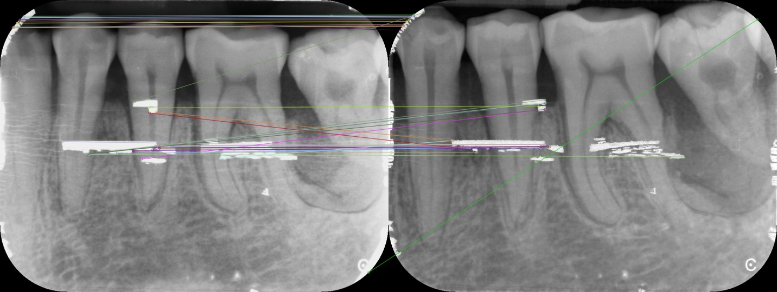

**Figure 17. Feature matching between superimposition and the “gold standard” using SIFT.**

In our next attempt, instead of trying to compare the two images, we compared each superimposition to all 23 “gold standard” images. And the logic is that if by some measure of similarity, the algorithm can tell that the superimposition is more similar to its corresponding “gold standard” than all the other ones, then one can say with some confidence that the superimposition was successful. We used structural similarity (SSIM)27 as the way of measurement. However, the results were not very promising (see figure 18).

As shown in figure 18, superimposition 2 was matched to be the most similar to “gold standard” 8. In fact all 23 superimposed images were matched to be the most similar to “gold standard” 8 (not shown here). One possible explanation for this is that the artifact themselves contributed so little to the overall structural similarity comparing to the teeth background. So, as a result, the algorithm is in fact almost only measuring the simialrity of the teeth. And as all superimposition was done on the same teeth background, if that background is the most similar to the teeth in “gold standard” 8, it would make sense for all superimpostions to be matched to it. In conclusion, given the shifted frame of the background and how little the artifacts contribute to the overall image features, our attempts to validate the superimposition have not yielded much success.

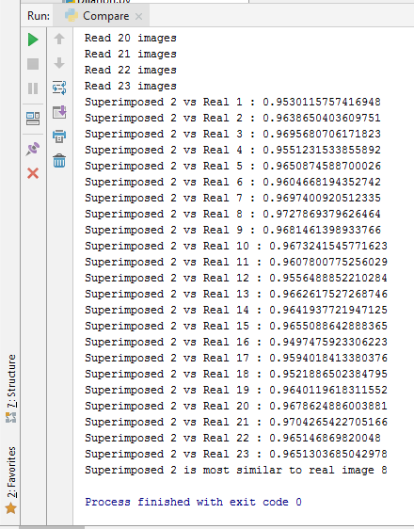

**Figure 18. Structural similarity between superimposition 2 and all “gold standard” images.**

**Conclusions and Future Directions**

In conclusion, in order to eventually study and predict the effect of PSP-damage-induced dental X-ray artifacts on clinical diagnosis and to give suggestions to clinician as in when to discard a sensor, we segmented the artifacts, clustered them into 5 meaningful groups and superimposed them onto clean teeth background to create artifact-containing teeth images. Though, there are limitations and space for improvements. The DBSCAN algorithm were able to pick up and segment most of the high intensity artifacts, but less so for the low intensity ones. There may also be a need to omit certain features and change the choice of *k* for *k-prototypes*. And the validation for our superimposition process has not been successful. Thus, in the future, study could be done on detecting and segmenting more subtle artifacts from the images; optimizing the number of clusters in *k-prototypes* and the features selected in order to get a more meaningful grouping; and establishing a more robust way of validating the superimposition.

Our study can provide preparatory steps and materials for future investigation on the effect of dental artifacts on diagnostic abilities. The dataset of superimposed teeth images that we generated can be used to obtain labels of whether diagnosis will be affected for each artifact image. And then based on the characterization of artifacts within the images, a predictive model can be built to learn the relationship between the features and the labels and, ultimately, to classify future PSPs and decide whether they should be discarded or not. Alternatively, provided that we have enough data, supervised deep learning algorithms such as CNN that take input of the entire superimposed image rather than the hand-engineered features could also be used for learning and predicting the label. Our study also provides a pipeline of segmentation and unsupervised clustering that can be used in future studies on related subjects.

References

1. Hildebolt CF, Couture RA, Whiting BR. 2000. Dental photostimulable phosphor radiography. Dent Clin North Am. 44:273-97.
2. Wenzel A, Frandsen E, Hintze H. 1999. Patient discomfort and cross-infection control in bite-wing examinations with a storage phosphor plate and a CCD-based sensor. J Dent. 27:243-6.
3. Gulsahi A, Secgin CK. 2016. Assessment of intraoral image artifacts related to photostimulable phosphor plates in a dentomaxillofacial radiology department. Niger J Clin Pract. 19:248–53.
4. 安田 光慶, 加藤 京一, 黒澤 駿, 吉川 宏起, 佐藤 久弥, 高橋 俊行, 岩井 譜憲, 渡辺 裕之, 中澤 靖夫. 2013. ディジタルマンモグラフィの輝尽性蛍光体プレート劣化による臨床画像への影響. 日放技学誌. 69(4): 393-399.
5. Ergun S., Güneri P., Ilgüy D., Ilgüy M., 2009. Boyacioglu H. How many times can we use a phosphor plate? A preliminary study. Dentomaxillofac Radiol. 38:42–47.
6. Kalathingal SM *et al.* 2010. Rating the Extent of Surface Scratches on Photostimulable Storage Phosphor Plates in a Dental School Environment. Dentomaxillofac Radiol. 39(3):179–183.
7. Çalışkan A, Sumer AP. 2017. Definition, classification and retrospective analysis of photostimulable phosphor image artifacts and errors in intraoral dental radiology. Dentomaxillofac Radiol. 46: 20160188.
8. van der Walt S, Schönberger JL, Nunez-Iglesias J, Boulogne F, Warner JD, Yager N, Gouillart E, Yu T and the scikit-image contributors. 2014. Scikit-image: Image processing in Python. Peer J. 2:e453. doi: http://dx.doi.org/10.7717/peerj.453.
9. Lewis JP. 1995. Fast Normalized Cross-Correlation. Vision Interface.
10. Acharya T and Ray AK. 2005. Image Processing: Principles and Applications. Hoboken (NJ): Wiley-Interscience. 425p.
11. Pizer SM, Amburn E, Austin J, Cromartie R, Geselowitz A, Greer T, ter Haar Romeny B, Zimmerman J, Zuiderveld K. 1987. Adaptive Histogram Equalization and Its Variations. Comp. Vis. Graphics & Im. Proc. 39: 355-368.
12. Ester M, Kriegel H, Sander J, Xu X. 1996. A density-based algorithm for discovering clusters in large spatial databases with noise. Proc. 2nd Int. Conf. Knowledge Discovery and Data Mining. 226-231.
13. Pedregosa F *et al.* 2011. Scikit-learn: Machine Learning in Python. J Mach Learn Res. 12:2825-2830.
14. Jones E, Oliphant E, Peterson P and others. 2001. SciPy: Open Source Scientific Tools for Python. Available from: http://www.scipy.org/.
15. Bradski G. 2000. The OpenCV Library. Dr. Dobb’s Journal of Software Tools. 120:122-125.
16. Ramer U. 1972. An iterative procedure for the polygonal approximation of plane curves. Comput Gr Image Process. 1(3): 244-256. doi:10.1016/S0146-664X(72)80017-0.
17. Douglas D and Peucker T. 1973. Algorithms for the reduction of the number of points required to represent a digitized line or its caricature. Cartographica. 10(2), 112–122. doi:10.3138/FM57-6770-U75U-7727.
18. Huang Z. 1997. Clustering large data sets with mixed numeric and categorical values. Proceedings of the First Pacific Asia Knowledge Discovery and Data Mining Conference; Singapore: World Scientific, p, 21–34.
19. MacQueen JB. 1967. Some methods for classification and analysis of multivariate observations. Proceedings of the 5th Berkeley Symposium on Mathematical Statistics and Probability. Berkeley, California: University of California Press, p, 281-297.
20. Huang Z. 1998. Extensions to the k-modes algorithm for clustering large data sets with categorical values. Data Min Knowl Disc. 2(3):283-304.
21. de Vos N. 2013. Kmodes. Available from: <https://github.com/nicodv/kmodes>.
22. van der Walt S , Colbert SC, Varoquaux G. 2011. The NumPy Array: A structure for efficient numerical computation. Comput Sci Eng. 13(2): 22-30. doi: 10.1109/MCSE.2011.37.
23. Canny J. 1986. A computational approach to edge detection. IEEE Trans. Pattern Analysis and Machine Intelligence. 8(6):679–698.
24. Donoho D. 2000. High-Dimensional Data Analysis: The Curses and Blessings of Dimensionality. AMS Math Challenges Lecture.
25. Liou CY, Huang JC, Yang WC. 2008. Modeling word perception using the Elman network. Neurocomputing. 71 (16–18): 3150. doi:10.1016/j.neucom.2008.04.030.
26. Lowe DG. 1999. Object recognition from local scale-invariant features. Proceedings of the International Conference on Computer Vision. 2: 1150–1157.
27. Wang Z, Bovik AC, Sheikh HR, Simoncelli EP. 2004. Image quality assessment: From error visibility to structural similarity. IEEE Transactions on Image Processing. 13(4): 600-612.